**Database Management System for JIO HOTSTAR**

**Name :** Praveen Choudhary

**Prn :** 23070243065

**Subject :** Data Engineering

Drive Link: <https://drive.google.com/drive/folders/15V4RWHrTSWL6ALuTk2vA6mVT7IRG61ld?usp=sharing>

1. **Generating Synthetic Data:**

Raw Data is generate from <https://mostly.ai/> .

1. **Flow Chat and ERD Diagram:**

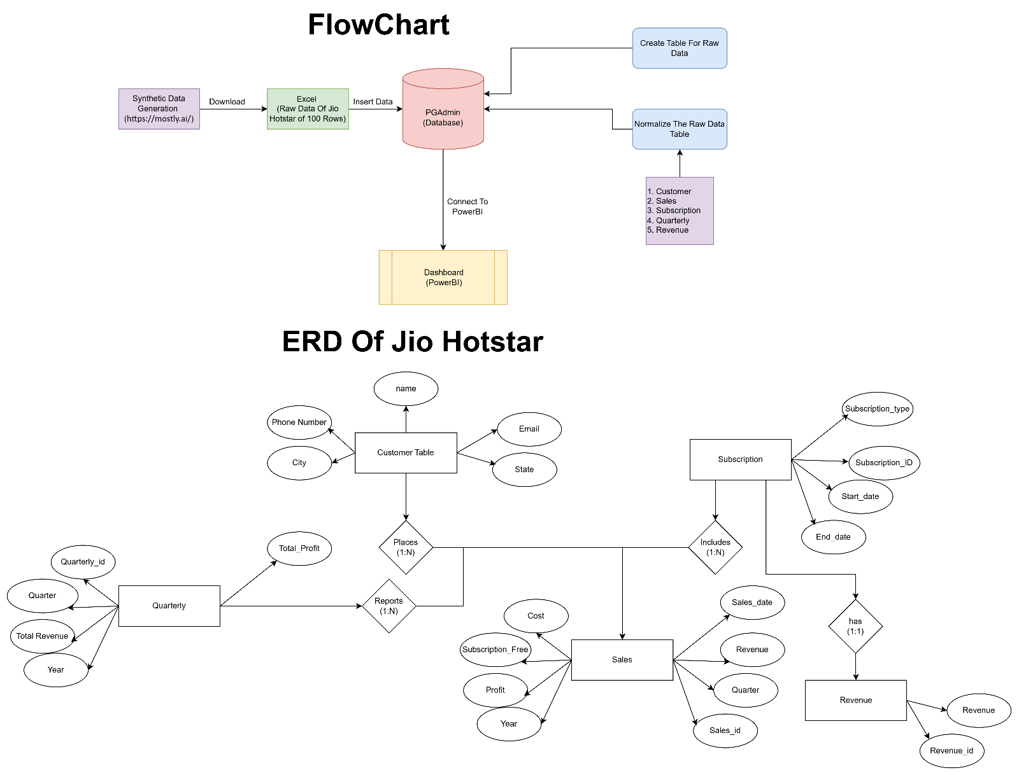

2

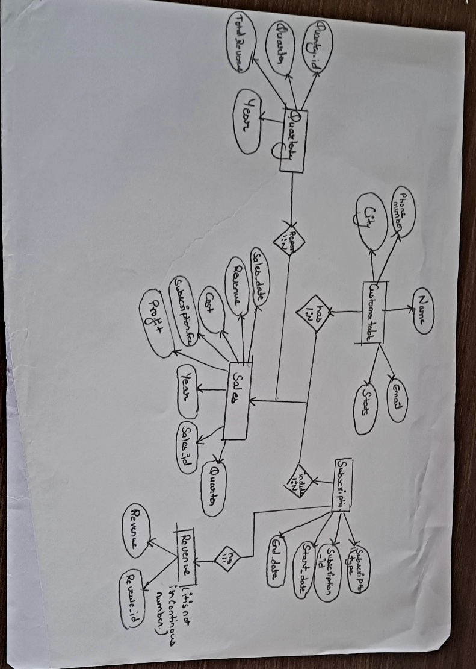

**ERD (Entity-Relationship Diagram) Description:**

**Entities and Attributes:**

1. **Customer**
   * **Customer_ID (PK)**
   * **Customer_Name**
   * **Email**
   * **Phone_Number**
   * **City**
   * **State**
2. **Subscription**
   * **Subscription_ID (PK)**
   * **Subscription_Type**
   * **Start_Date**
   * **End_Date**
3. **Sales**
   * **Sales_ID (PK)**
   * **Customer_ID (FK to Customer)**
   * **Subscription_ID (FK to Subscription)**
   * **Sales_Date**
   * **Subscription_Fee**
   * **Revenue**
   * **Cost**
   * **Profit**
   * **Year**
   * **Quarter**
   * **(FK to Quarterly on Year and Quarter)**
4. **Revenue**
   * **Revenue_ID (PK)**
   * **Subscription_ID (FK to Subscription)**
   * **Revenue**
5. **Quarterly**
   * **Quarterly_ID (PK)**
   * **Year (Unique constraint with Quarter)**
   * **Quarter (Unique constraint with Year)**
   * **Total_Revenue**
   * **Total_Profit**

**Relationships:**

* **Customer to Sales: One-to-Many (A customer can have many sales, but each sale belongs to one customer).**
* **Subscription to Sales: One-to-Many (A subscription can be linked to many sales, but each sale references one subscription).**
* **Subscription to Revenue: One-to-One (Each subscription has a revenue entry).**
* **Quarterly to Sales: One-to-Many (A quarter can have many sales, but each sale belongs to one quarter based on year and quarter).**

1. **Insert Data Into Data Base**

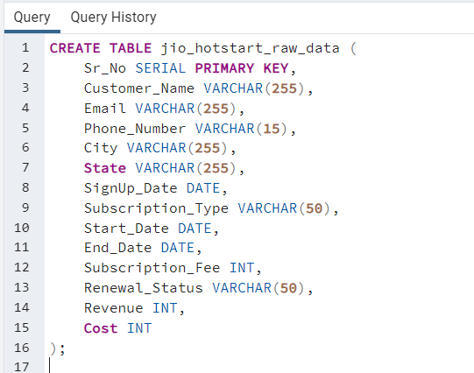

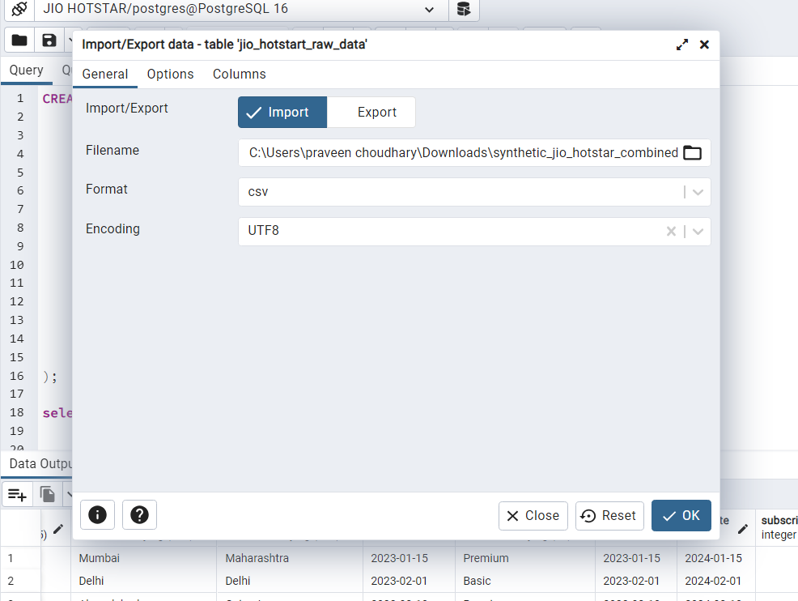

Show the raw data:

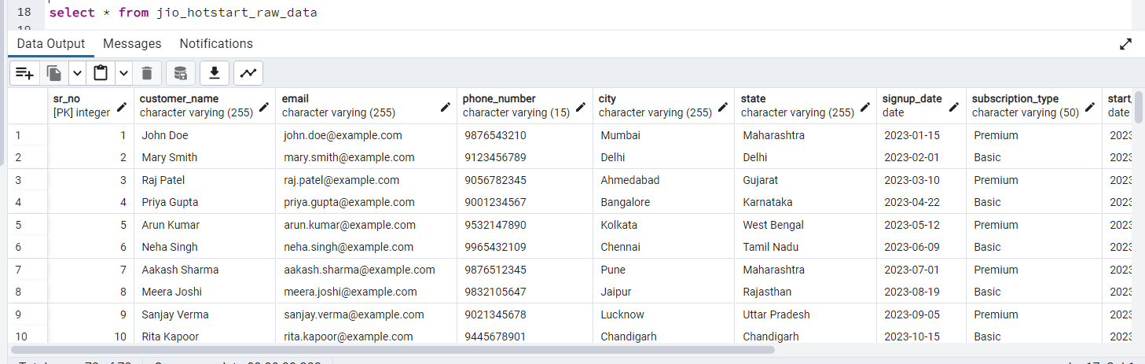

**Step 1: Create Tables for Normalization**

* 1. Create Customer Table

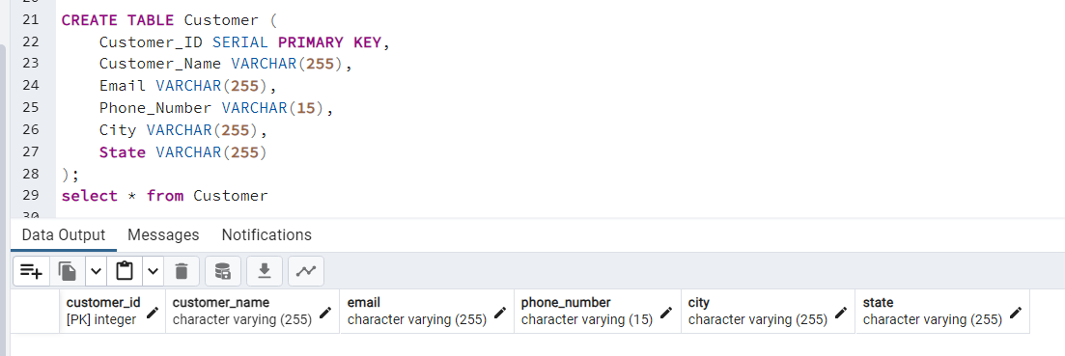

* 1. Sales Table:

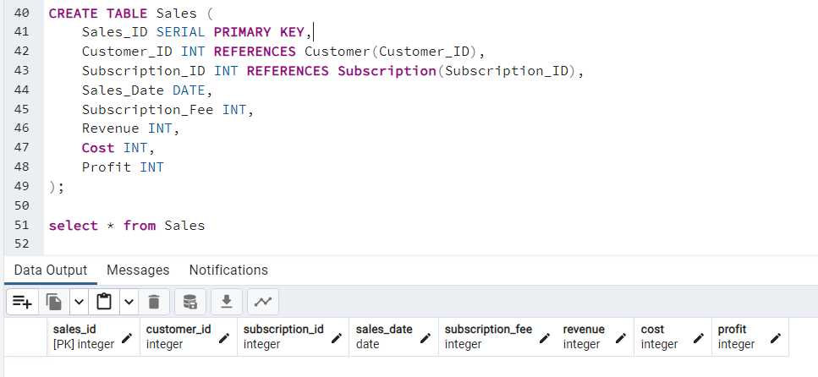

* 1. Subscription Table:



* 1. Revenue Table:

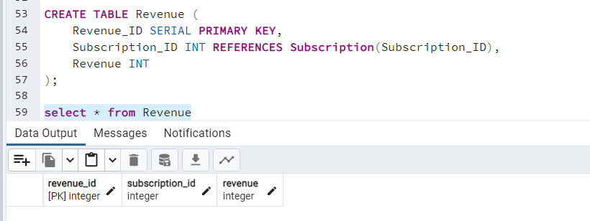

* 1. Quarterly Table:

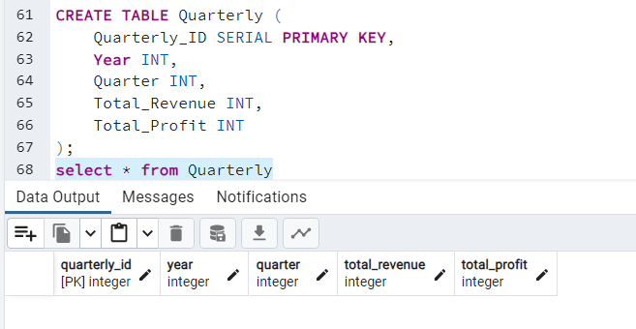

**Step 2: Insert Data from jio_hotstart_raw_data**

2.1 Insert Customer Data:

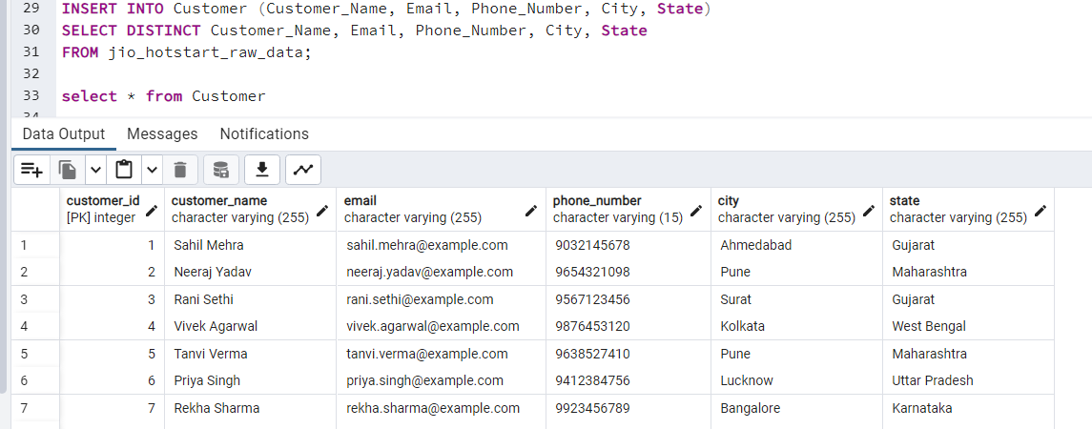

2.2 Insert Subscription Data:

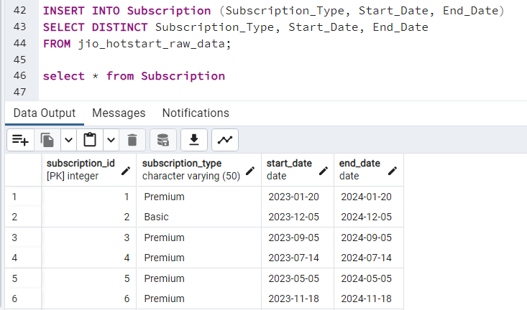

2.3 Insert Sales Data:

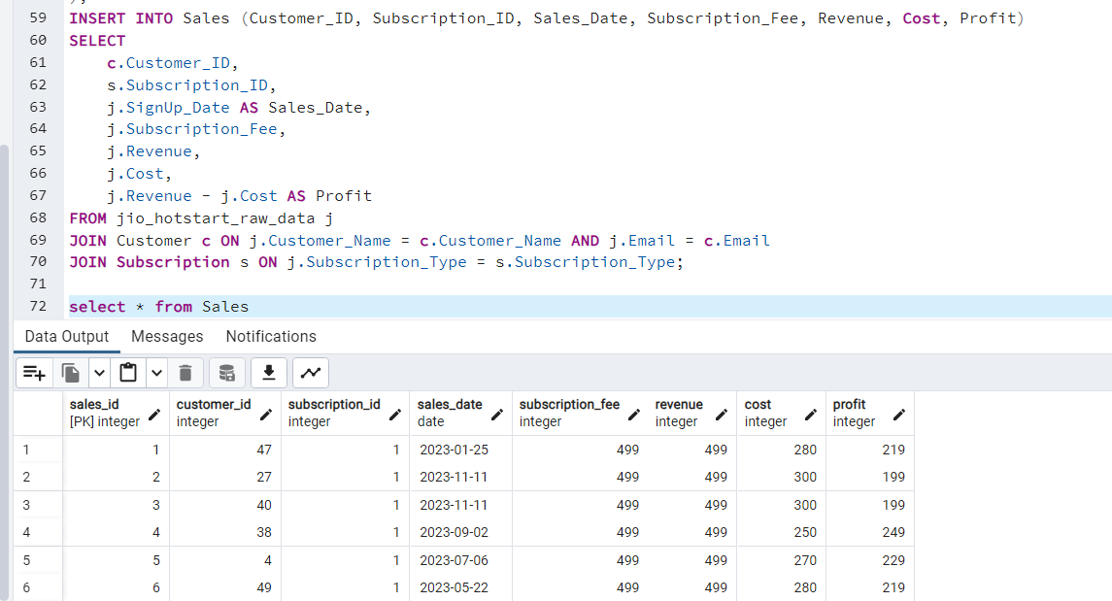

2.4 Insert Revenue Data:

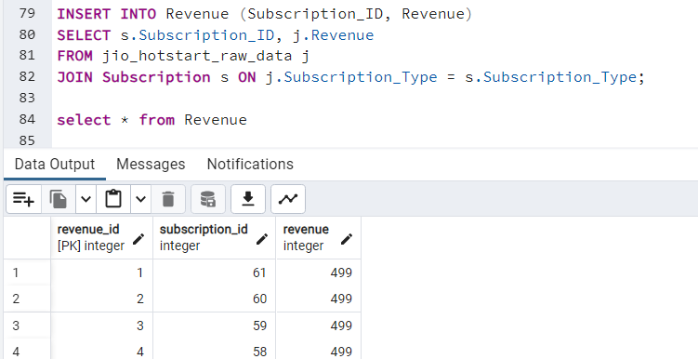

* 1. Insert Quarterly Data:

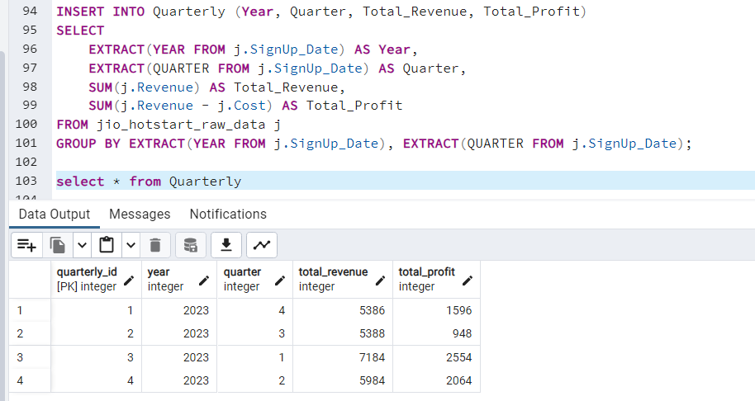

* 1. Make Related Between the Quarterly And Sales Table

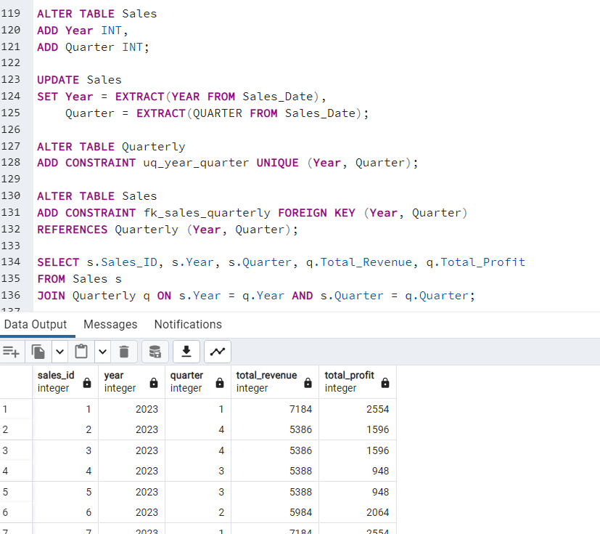

1. **Drop jio_hotstart_raw_data**

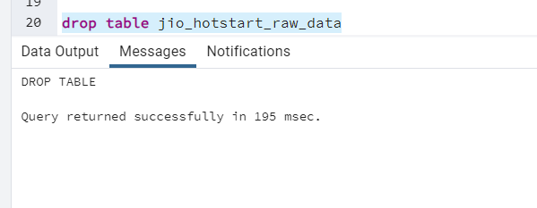

1. **ERD Diagram For Jio_Hotstar DataBase:**

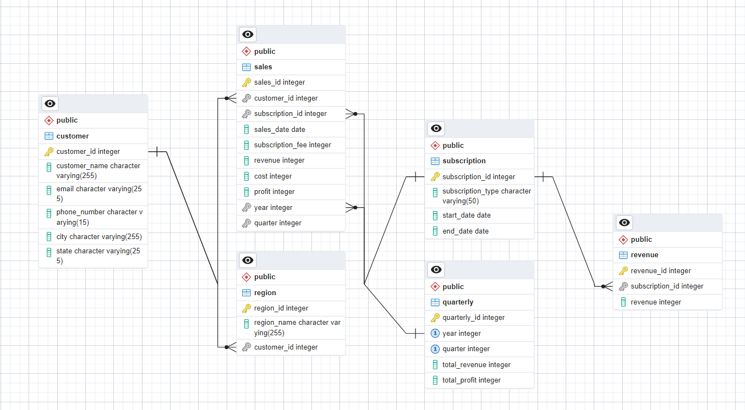

1. **Connect PGAdmin To PowerBi:**

For connection use server as localhost:5433 and pgadmin database name JIO_HOTSTAR

After connection we get all the table:

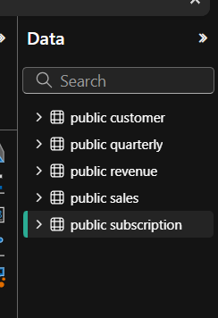

**Some Query**

* 1. **Query to Get Total Revenue, Profit, and Number of Customers by Subscription Type:**

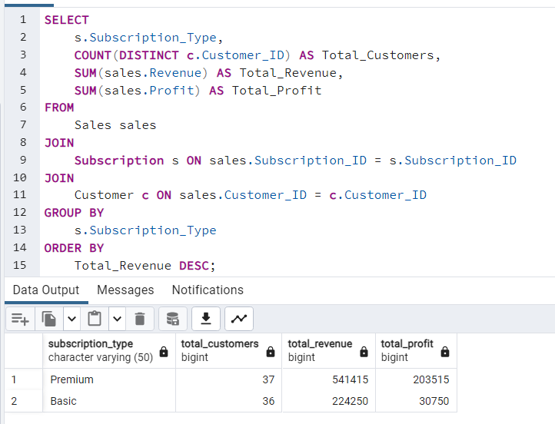

Subscription Summary: Premium subscriptions generate higher revenue (₹541,415) and profit (₹203,515) compared to Basic, despite similar customer counts.

* 1. **Query to Get Quarterly Revenue and Profit Breakdown:**

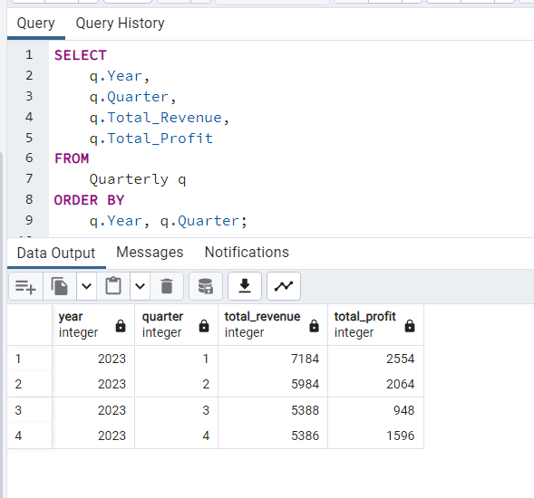

Quarterly Performance: Revenue and profit peaked in Q1 2023 and steadily declined through Q4, indicating potential seasonality or operational changes.

1. **Dashboard 1 For Business Performance Dashboard**

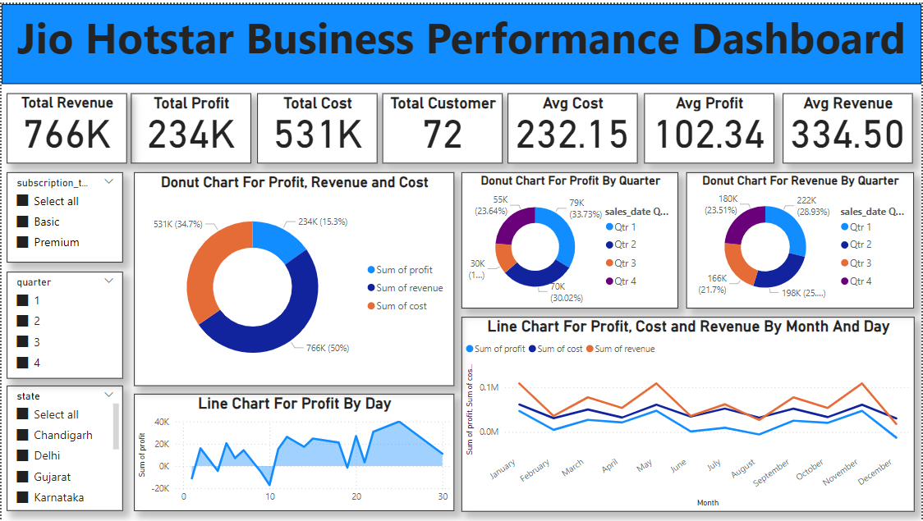

**Jio Hotstar Business Performance Dashboard Overview**

The Jio Hotstar Business Performance Dashboard provides a comprehensive view of the key metrics related to the company’s financial and customer performance. It is designed to offer actionable insights through clear visualizations and summary statistics. Below are the key components of the dashboard:

**1. Key Performance Indicators (KPIs):**

* Total Revenue: Displays the total income generated (766K) across all subscription types.
* Total Profit: Shows the net earnings (234K) after deducting costs.
* Total Cost: Represents the operational expenses (531K) incurred.
* Total Customers: Indicates the total number of customers (72).
* Average Cost per Customer: The mean cost (232.15K) calculated per customer.
* Average Profit per Customer: The mean profit (102.34K) calculated per customer.
* Average Revenue per Customer: The average income (334.50K) generated per customer.

**2. Visualizations:**

* **Donut Charts:**
  + Profit, Revenue, and Cost Distribution: Highlights the proportion of profit, revenue, and cost in total operations.
  + Profit and Revenue by Quarter: Shows the quarterly breakdown for better time-based analysis. For instance, Quarter 3 contributes significantly to profit (33.73%).
* **Line Charts:**
  + Profit by Day: Depicts daily profit trends, showing fluctuations and peak performance days.
  + Monthly Trends: Tracks monthly changes in profit, cost, and revenue to identify seasonal patterns.

**3. Filters:**

* Subscription Type Filter: Allows segmentation of data based on subscription plans (e.g., Basic, Premium).
* Quarter Filter: Enables analysis of specific quarters (1, 2, 3, or 4).
* State Filter: Provides insights by region, such as Chandigarh, Delhi, Gujarat, and Karnataka.

**4. Insights from Visuals:**

* The donut charts reveal a balanced revenue and cost structure, with clear profitability in Q3.
* Line charts highlight patterns in profitability over time, helping to pinpoint days or months with optimal performance or high costs.
* Regional and subscription-based filters allow focused analysis to aid in strategic decision-making.

1. **Dashboard 2 For Region wise Performance Dashboard**

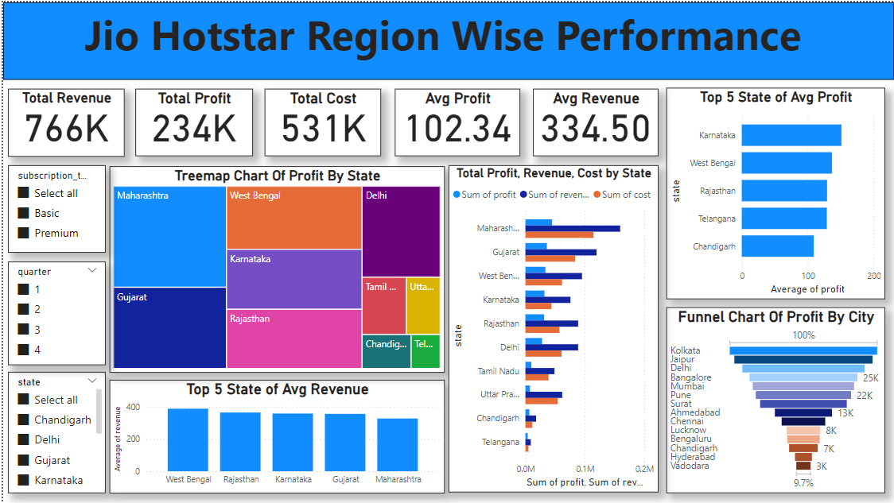

**Jio Hotstar Region-Wise Performance Dashboard**

This dashboard provides a detailed analysis of Jio Hotstar's performance across different states and cities, highlighting key regional insights and overall business metrics.

Key Components and Visualizations

1. Key Performance Indicators (KPIs):
   * Total Revenue: 766K, showcasing the total income generated across all regions.
   * Total Profit: 234K, reflecting the net earnings after subtracting costs.
   * Total Cost: 531K, representing the operational expenses across regions.
   * Average Profit per Customer: 102.34K, indicating the mean profit per user.
   * Average Revenue per Customer: 334.50K, showing the income generated on average per customer.
2. Treemap Chart for Profit by State:
   * Displays a hierarchical view of profits by state, with larger blocks representing higher profits. Maharashtra, West Bengal, Gujarat, and Karnataka are prominent contributors.
3. Bar Chart for Total Profit, Revenue, and Cost by State:
   * Highlights the financial distribution per state. States like Maharashtra and Gujarat show higher revenue and profit margins compared to others.
4. Top 5 States by Average Profit:
   * Karnataka leads with the highest average profit, followed by West Bengal, Rajasthan, Telangana, and Chandigarh.
5. Top 5 States by Average Revenue:
   * West Bengal, Rajasthan, Karnataka, Gujarat, and Maharashtra are the leading states in terms of average revenue generation.
6. Funnel Chart for Profit by City:
   * Highlights profit contribution from major cities, with Kolkata, Jaipur, and Delhi being the top contributors.

**Conclusions**

From the Business Performance Dashboard:

* Jio Hotstar has a healthy revenue stream, with a total revenue of 766K and a profit margin of 234K.
* Quarter-wise performance indicates a significant profit contribution from Q3 (33.73% of total profit).
* Monthly trends reveal key periods of high profit and cost, enabling better planning for peak times.

From the Region-Wise Performance Dashboard:

* Maharashtra, Gujarat, and Karnataka stand out as key states in terms of revenue and profitability.
* Cities like Kolkata, Jaipur, and Delhi are major profit contributors, suggesting a strong customer base in urban regions.
* Karnataka leads in average profit, indicating higher profitability per customer in this state.